SHELL SCRIPTING & AUTOMATION
- Shell Scripting Fundamentals
  - Variables & Data Types
  - Reading User Input
  - Using Variables in Calculations
  - Conditionals & Loops
  - Combining Conditionals with Loops
- Functions & Debugging
  - Functions in Shell Scripting
  - Using Loops Inside Functions
  - Local Variables in Functions
  - Debugging & Error Handling
- Automation & Security
  - Automating Tasks
  - Log File Analysis & Reporting
  - Linux Security & Permissions
  - SSH Keys & Advanced File Permissions
Variables & Data Types in Shell Scripting
In Shell scripting, variables are used to store values such as numbers, strings, or even the output of a command. The good news is, you don’t need to declare the type of the variable upfront (like in other programming languages). The shell automatically understands what type the variable is based on the value it holds.
Declaring Variables
To declare a variable, you simply assign a value to it without spaces around the = sign.
Syntax:
variable_name=value
Example:
Accessing Variables:
To access the value of a variable, you simply prefix it with a dollar sign ($).
echo $my_name
Output:
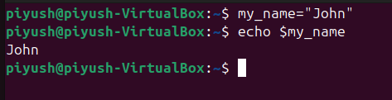
Types of Variables:
Shell scripting primarily deals with strings and numbers. However, since everything in shell scripting is treated as a string, numerical operations on variables will treat them as integers.
String Variables: You can store strings (text) in variables.
Example:
greeting="Hello, World!"
echo $greeting
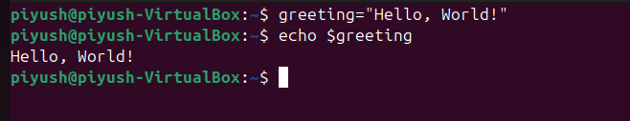
Integer Variables: To store numbers, you can directly assign integers to variables.
Example:
age=25
echo $age
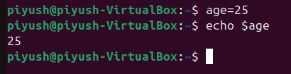
However, note that no quotes are needed around numbers.
Reading User Input
In shell scripting, read is the command used to capture user input and store it in a variable. I'll provide an example and explain how to run it step-by-step to make sure it's smooth on your system.
Open Your Terminal
- Type nano script.sh to create and open a new shell script file.
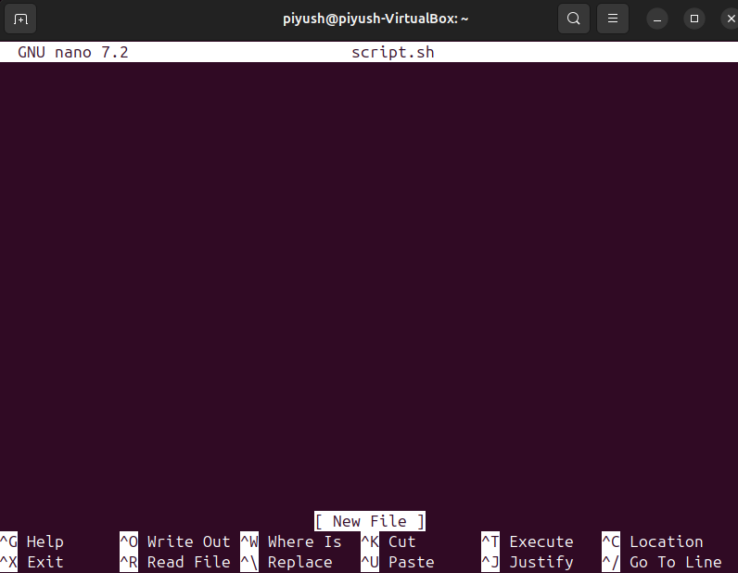
Writing the Script
Once you are inside the nano editor, type the following code for reading input:
#!/bin/bash
# Simple script to read user input
echo "Please enter your name:"
read name # This will capture the input and store it in the 'name' variable
echo "Hello, $name! Welcome to Shell Scripting!"
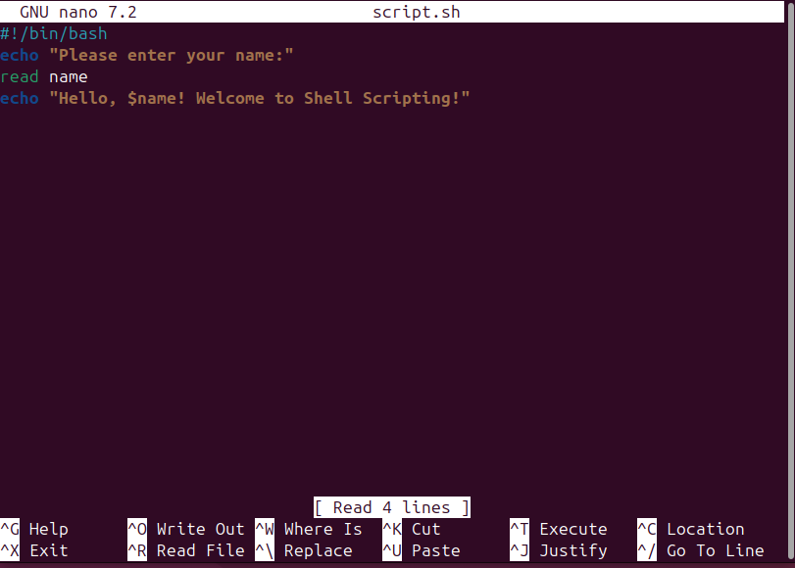
3. Save and Exit
- To save the file in nano, press Ctrl + O and hit Enter.
- To exit nano, press Ctrl + X.
4. Make the Script Executable
In the terminal, type:
chmod +x script.sh
This makes your script executable.
5. Run the Script
Now, run the script by typing:
./script.sh
You should see the message:
Please enter your name:
You can type in your name and press Enter. Then, it will greet you with:
Hello, [Your Name]! Welcome to Shell Scripting!
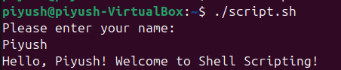
In Summary:
- read captures user input and stores it in a variable.
- You can then use that variable in your script to display or manipulate data.
- Run the script using ./script.sh after making it executable.
Using Variables in Calculations
To perform calculations with integer variables, use the $(( )) syntax.
First let’s create one shell script file:
nano calculation.sh
num1=10
num2=5
sum=$((num1 + num2))
echo "Sum: $sum"
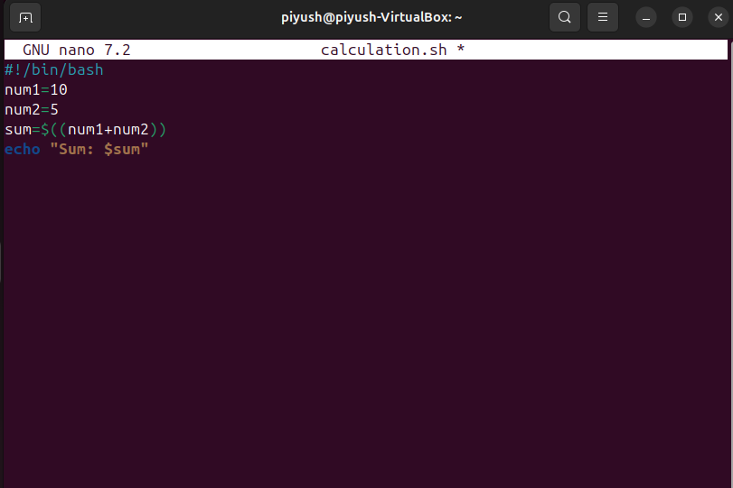
Save the file with ctrl +x and Y then Enter.
Now, make it executable:
chmod +x calculation.sh
Now the file is executable.
Let’s run the file:
./calculation.sh
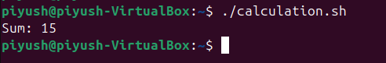
Environment Variables:
These are predefined variables in your system, such as $HOME, $PATH, and others.
echo "Your home directory is: $HOME"
echo "The current path is: $PATH"
Special Variables:
There are also some special variables that you might encounter when working with scripts:
- $0 → The name of the script.
- $1, $2, ..., $n → Command-line arguments passed to the script.
- $# → The number of arguments passed.
- $? → The exit status of the last command.
- $! → The process ID of the last background command.
Example:
echo "Script Name: $0"
echo "First Argument: $1"
echo "Total Arguments: $#"
Unset Variables
If you want to remove a variable, you can use the unset command.
unset my_name
Conditionals & Loops in Shell Scripting
Creating & Running a Shell Script
First, let’s set up a script file, make it executable, and then run it.
Create a Script File: Type the following command to create a new script file using nano:
nano conditional_example.sh
- Add Commands to the Script
#!/bin/bash
# This script demonstrates conditionals and loops in bash.
# Get the current day of the week
day=$(date +%A)
echo "Today is $day."
# Using if-elif-else conditionals
if [ "$day" == "Monday" ]; then
echo "Start of the week!"
elif [ "$day" == "Friday" ]; then
echo "Almost the weekend!"
else
echo "Just another day!"
fi
# Using a for loop to print numbers
echo "Printing numbers from 1 to 5:"
for i in {1..5}; do
echo $i
done
3. Save and Exit Nano
- Press CTRL + X to exit.
- When prompted to save, press Y (Yes).
- Press Enter to confirm the file name.
4. Make the Script Executable
To run a script, you need to make it executable. Here’s how:
Change Script Permissions
In the terminal, run the following command to give the script execution permissions:
chmod +x conditional_example.sh
5. Run the Script
Now, you can run the script by typing:
./conditional_example.sh
Output:
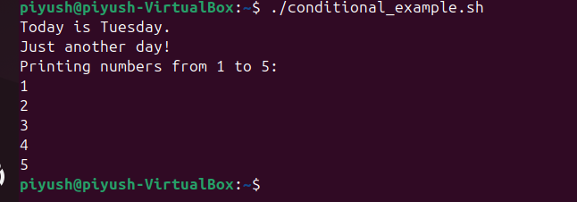
Conditional Statements
if-else Example
Conditionals allow you to make decisions within your scripts. Here’s an example where we check the current day and print different messages.
#!/bin/bash
day=$(date +%A)
if [ "$day" == "Monday" ]; then
echo "It's the start of the week!"
else
echo "It's not Monday, it's $day."
fi
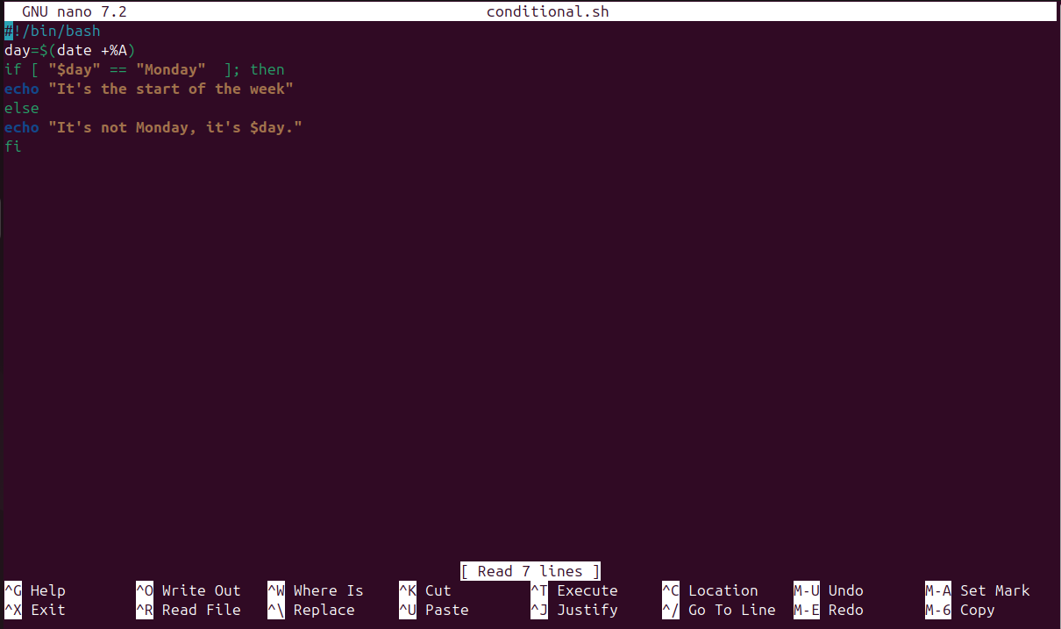
Explanation:
- [ "$day" == "Monday" ]: Checks if the current day is Monday.
- If true, it prints "It's the start of the week!", otherwise, it prints "It's not Monday, it's [day]".
Output:
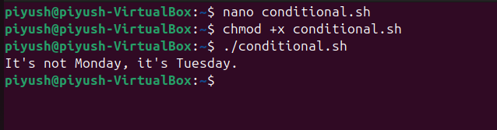
Loops in Shell Scripting
Loops help automate repetitive tasks. Let’s explore for, while, and until loops
for Loop Example
#!/bin/bash
for i in {1..5}; do
echo "This is loop iteration $i"
done
Explanation:
- This loop will print "This is loop iteration X" where X is the number from 1 to 5.
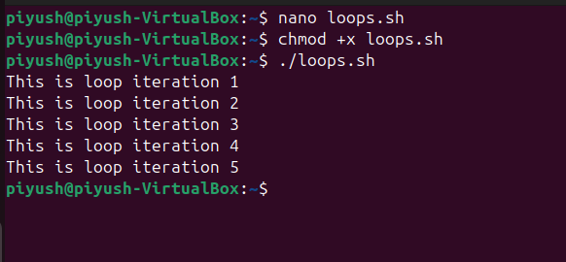
while Loop Example
#!/bin/bash
count=1
while [ $count -le 5 ]; do
echo "Current count: $count"
((count++)) # Increment count
done
Explanation:
- The while loop will print "Current count: X" until $count is greater than 5.
Step to Run:
- Create the script using nano while_loop_example.sh.
- Add the script.
- Save, exit, and make it executable using chmod +x while_loop_example.sh.
- Run it with ./while_loop_example.sh.
Output:
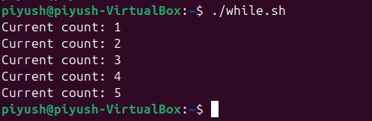
until Loop Example
#!/bin/bash
count=1
until [ $count -gt 5 ]; do
echo "Current count: $count"
((count++)) # Increment count
done
Explanation:
- The until loop works opposite to the while loop. It continues running until $count is greater than 5.
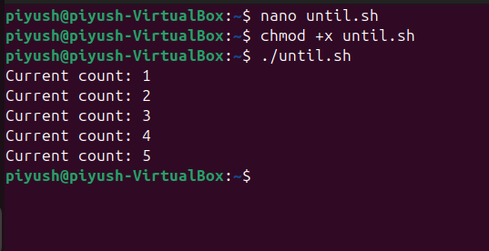
Combining Conditionals with Loops
You can combine loops with conditionals to create a more powerful script.
Example:
Let’s create a script that checks if a list of files exists.
#!/bin/bash
files=("file1.txt" "file2.txt" "file3.txt")
for file in "${files[@]}"; do
if [ -e "$file" ]; then
echo "$file exists."
else
echo "$file does not exist."
fi
done
Explanation:
- The script loops through an array of files, checks if each one exists, and prints a message accordingly.
First we have created three files:
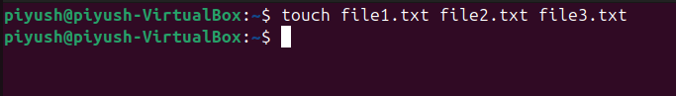
Then created the script.
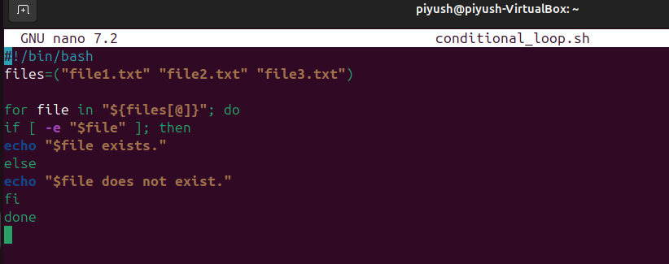
Output:
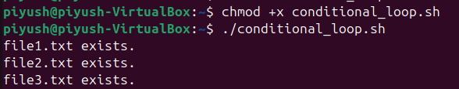
Summary of Conditional Statements & Loops
- Conditionals (if, else, elif) allow decision-making in scripts.
- Loops (for, while, until) repeat tasks until a condition is met.
- Combine loops and conditionals for more complex automation.
- Don’t forget to create and execute the scripts as shown.
Functions in Shell Scripting
What Are Functions in Shell Scripting?
Functions in Bash allow us to:
- Group reusable code
- Make scripts more organized & readable
- Avoid repetition
Instead of writing the same block of code multiple times, we can define a function once and call it whenever needed.
Creating & Calling a Function
Basic Function Syntax:
function function_name {
# Commands go here
}
OR
function_name() {
# Commands go here
}
Example: Simple Function
#!/bin/bash
# Define a function
greet() {
echo "Hello, welcome to Shell Scripting!"
}
# Call the function
greet
Steps to Run:
Open terminal and create a script file:
nano function_example.sh
- Add the script.
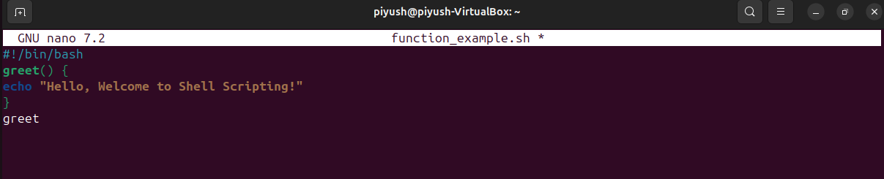
- Save & exit (CTRL + X, then Y, then Enter).
Make it executable:
chmod +x function_example.sh
- Run the script:
./function_example.sh
Output:
Hello, welcome to Shell Scripting!
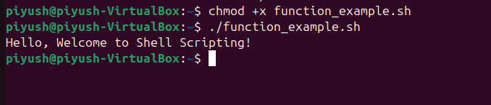
Function with Arguments
Functions can take arguments like command-line scripts.
Example: Function with Parameters
#!/bin/bash
# Function that takes parameters
greet_user() {
echo "Hello, $1! Your role is $2."
}
# Call the function with arguments
greet_user "Alice" "Data Engineer"
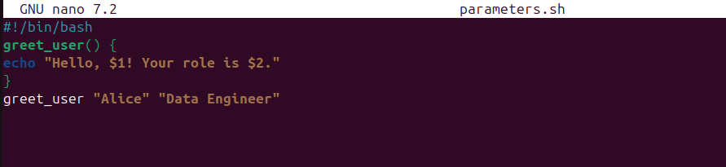
Output:
Hello, Alice! Your role is Data Engineer.
Explanation:
- $1 refers to the first argument (Alice).
- $2 refers to the second argument (Data Engineer).
Return Values from Functions
A function can return a value using return or echo.
Example: Function Returning a Value
#!/bin/bash
# Function to add two numbers
add_numbers() {
sum=$(( $1 + $2 )) # Calculate sum
echo $sum # Print result
}
# Call function and capture result
result=$(add_numbers 5 10)
echo "The sum is: $result"
Output:
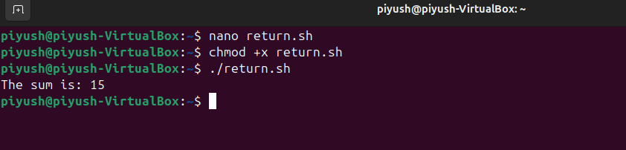
Function Using Conditional Logic
You can also use if-else inside a function.
Example: Check if a Number is Even or Odd
#!/bin/bash
check_number() {
if (( $1 % 2 == 0 )); then
echo "$1 is even."
else
echo "$1 is odd."
fi
}
# Call the function with different numbers
check_number 7
check_number 8
Output:
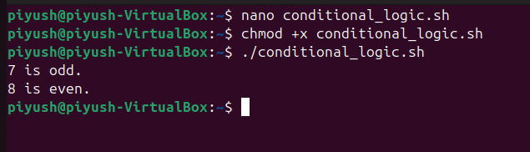
Using Loops Inside Functions
Loops can also be used inside functions.
Example: Print Numbers in a Range
#!/bin/bash
print_numbers() {
for i in $(seq $1 $2); do
echo "Number: $i"
done
}
# Call function with start and end values
print_numbers 1 5
Output:
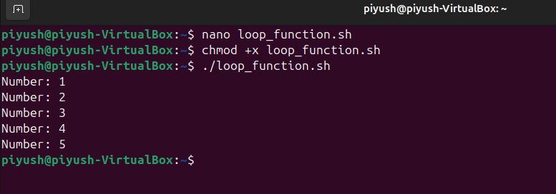
Local Variables in Functions
By default, variables inside functions are global. Use local to limit scope.
Example: Local Variables
#!/bin/bash
calculate_square() {
local num=$1
local square=$(( num * num ))
echo "Square of $num is $square"
}
calculate_square 4
Output:
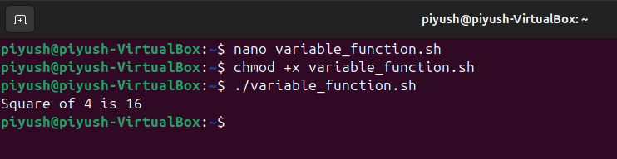
Function Calling Another Function
Functions can call other functions.
Example: Nested Function Calls
#!/bin/bash
function1() {
echo "This is function 1"
function2
}
function2() {
echo "This is function 2"
}
# Call the first function
function1
Output:
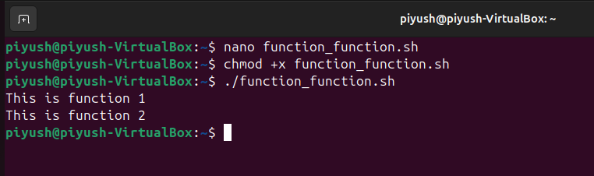
Summary
- Functions make scripts modular & reusable.
- They take arguments & return values.
- Loops & conditionals can be used inside functions.
- Use local to limit variable scope.
Shell Script Debugging & Error Handling
Debugging and error handling are essential when writing shell scripts to ensure smooth execution and avoid unexpected failures. Here’s how you can do it:
Debugging Shell Scripts
Use set -x for Debugging:
This option prints each command before execution, helping you track errors.
- Add this at the start of your script:
#!/bin/bash
set -x # Enable debugging
echo "Debugging Mode Enabled"
var="Hello World"
echo $var
set +x # Disable debugging
echo "Debugging Mode Disabled"
- You can also run a script in debug mode without modifying it:
bash -x script.sh
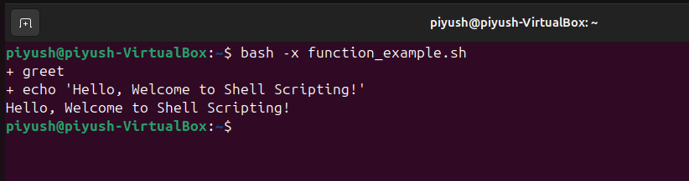
Handling Errors in Shell Scripts
Use set -e to Stop on Errors:This ensures the script exits immediately if any command fails.
#!/bin/bash
set -e # Exit on error
mkdir /root/test # This will fail without sudo, and script will stop here
echo "This line will not execute if the previous command fails"
Use trap to Handle Errors Gracefully:Trap allows you to catch errors and perform cleanup before exiting.
#!/bin/bash
trap 'echo "Error occurred! Cleaning up..."' ERR
cp file.txt /root/ # This will fail without permissions, triggering the trap
echo "Script completed successfully"
Automating Tasks in Shell Scripting
Automation is a key part of shell scripting, especially for Data Engineers and DevOps. We will cover two major automation use cases:
- Automated Backups
- Log File Analysis & Reporting
Automated Backups using Shell Scripting
Automating backups ensures data safety without manual intervention. We will create a script that:
- Creates a backup directory (if it doesn't exist).
- Copies important files to the backup location.
- Compresses the backup to save space.
- Runs automatically using cron (optional).
Creating the Backup Script
Steps:Open GNU nano to create the script:
nano backup.sh
Add the following script:
#!/bin/bash
# Define source and backup directories
SOURCE_DIR="$HOME/Documents"
BACKUP_DIR="$HOME/backup"
TIMESTAMP=$(date +"%Y-%m-%d_%H-%M-%S")
BACKUP_FILE="$BACKUP_DIR/backup_$TIMESTAMP.tar.gz"
# Create backup directory if it doesn't exist
mkdir -p "$BACKUP_DIR"
# Copy and compress the files
tar -czf "$BACKUP_FILE" "$SOURCE_DIR"
echo "Backup completed successfully: $BACKUP_FILE"
- Save and exit (Ctrl + X → Y → Enter)
- Make the script executable:
chmod +x backup.sh
Run the script:
./backup.sh
Output:
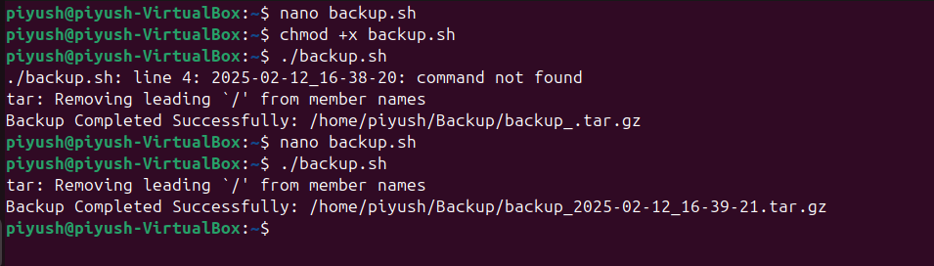
Automating with cron (Optional)
To schedule this script to run every day at 2 AM, add it to cron jobs:
crontab -e
Add the following line:
0 2 * * * /bin/bash $HOME/backup.sh
Now the script runs automatically.
Log File Analysis & Reporting
Log files store important system and application data. We will create a script to:
- Extract important log entries (errors, warnings, etc.).
- Generate a report.
- Send alerts if critical errors are found.
Creating the Log Analysis ScriptOpen GNU nano:
nano log_analysis.sh
Add the following script:
#!/bin/bash
# Define log file path (update this path as needed)
LOG_FILE="/var/log/syslog"
OUTPUT_FILE="$HOME/log_report.txt"
# Extract logs with "error" and "warning"
grep -iE "error|warning" "$LOG_FILE" > "$OUTPUT_FILE"
# Display the report
echo "Log analysis complete. Check the report: $OUTPUT_FILE"
- Save and exit (Ctrl + X → Y → Enter)
- Make the script executable:
chmod +x log_analysis.sh
Run the script:
./log_analysis.sh
Linux Security and Permissions
Security is essential in Linux, especially in multi-user environments and remote access setups. This guide will cover:
- User & File Security
- Advanced File Permissions
Since we're using Ubuntu in VirtualBox, we'll perform all steps in the Terminal. We will use GNU Nano 7.2 for editing configuration files.
User and File Security
Managing SSH Access and Keys (Secure Remote Login)
SSH (Secure Shell) allows secure remote access to your Linux system. Instead of using passwords, SSH keys are used for better security.
Step 1: Check if SSH is Installed
Open the Terminal and type:
sudo systemctl status ssh
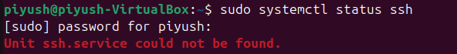
If SSH is not installed, install it using:
sudo apt update
sudo apt install openssh-server -y
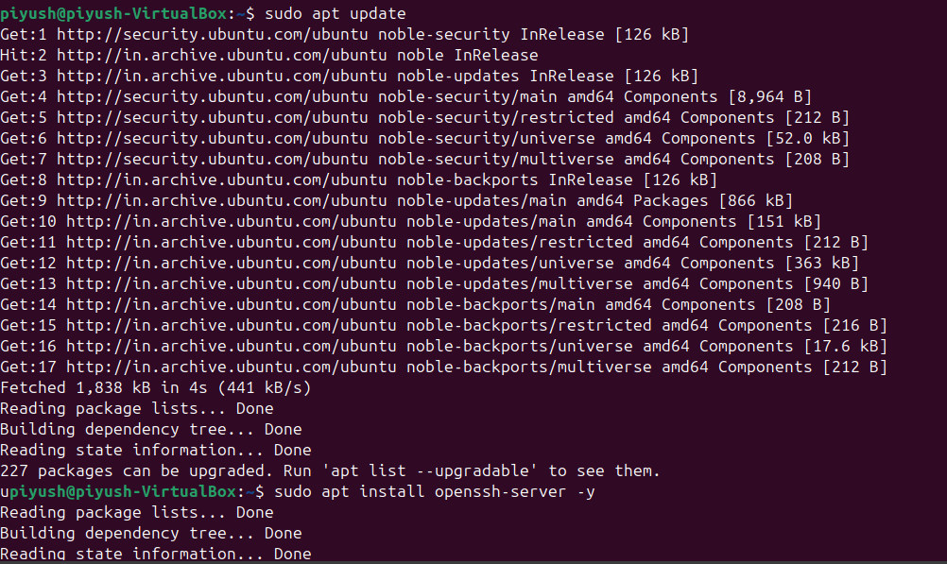
After installation, start and enable the SSH service:
sudo systemctl start ssh
sudo systemctl enable ssh
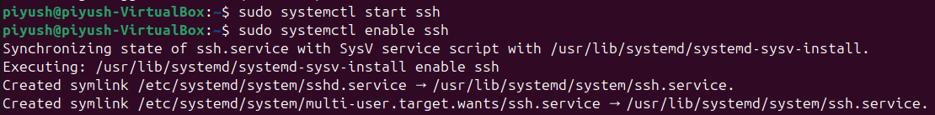
Step 2: Configure SSH for Security using Nano
Edit the SSH configuration file using GNU Nano 7.2:
sudo nano /etc/ssh/sshd_config
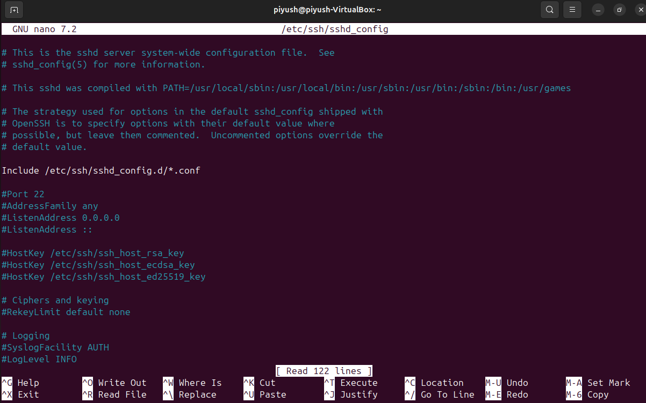
Find the following lines and modify them:
PermitRootLogin no
PasswordAuthentication no
PubkeyAuthentication yes
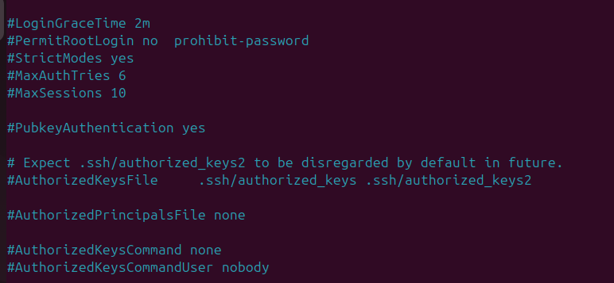
Explanation:
- PermitRootLogin no → Disables root login via SSH.
- PasswordAuthentication no → Disables password-based login.
- PubkeyAuthentication yes → Enables key-based login.
Save the file:
- Press CTRL + X to exit.
- Press Y to save.
- Press Enter to confirm.
Now, restart the SSH service for changes to take effect:
sudo systemctl restart ssh
Step 3: Generate an SSH Key Pair
Instead of using passwords, generate an SSH key pair (public & private key):
ssh-keygen -t rsa -b 4096 -C "your_email@example.com"
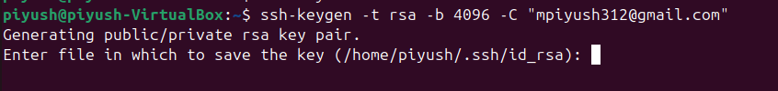
What happens here?
- The command creates two files inside the ~/.ssh/ directory:
  - id_rsa → Private key (Do not share this)
  - id_rsa.pub → Public key (This can be shared)
- When prompted for a passphrase, you can either enter one (recommended) or leave it empty.
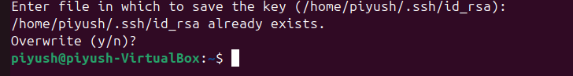
Step 4: Copy SSH Key to Remote Server
If you have a remote Linux system, transfer your public key to allow passwordless login:
ssh-copy-id user@remote-server
Now, try logging in without a password:
ssh user@remote-server
Why use SSH keys?
- Secure authentication (No need for passwords)
- Faster logins (Good for automation)
- Prevents brute-force attacks
Configuring Firewalls (iptables & UFW)
A firewall helps block unauthorized access to your system. In Ubuntu, we use UFW (Uncomplicated Firewall), which is easier than iptables.
Step 1: Enable UFW
To turn on the firewall, run:
sudo ufw enable
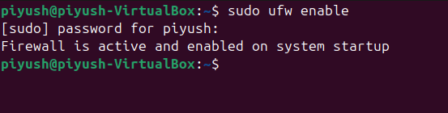
Step 2: Allow SSH Traffic
Since we are using SSH, we must allow SSH connections:
sudo ufw allow OpenSSH
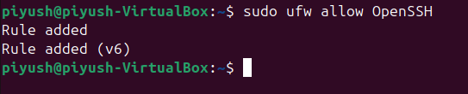
Step 3: Allow Web Traffic (Optional)
If you are hosting a web server, allow HTTP & HTTPS:
sudo ufw allow 80/tcp
sudo ufw allow 443/tcp
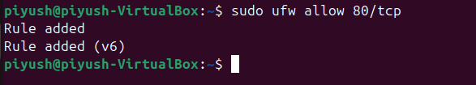
Step 4: Check Firewall Status
To verify which rules are applied, run:
sudo ufw status verbose
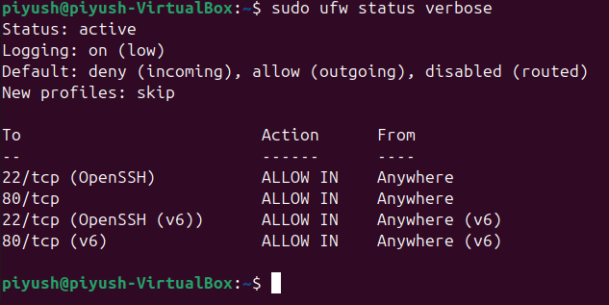
Why use UFW?
- Protects your system from unauthorized access.
- Simple and easy for beginners.
Advanced File Permissions
In Linux, every file has permissions that control who can read, write, or execute it.
Checking File Permissions
To check file permissions, use:
ls -l filename
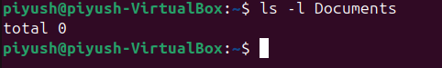
Example:
-rw-r--r-- 1 user group 1234 file.txt
- rw- → Owner can read & write
- r-- → Group can read only
- r-- → Others can read only
Changing File Permissions
Making a Script Executable
If you create a script and it’s not running, you need to make it executable:
chmod +x script.sh
Giving Full Permissions to the Owner
chmod 700 script.sh
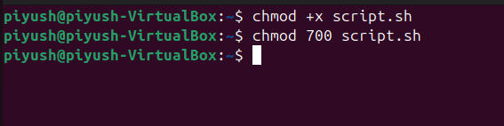
Explanation:
- 7 (Owner: Read, Write, Execute)
- 0 (Group: No permissions)
- 0 (Others: No permissions)
Changing File Ownership
To change the owner of a file, use:
sudo chown username filename
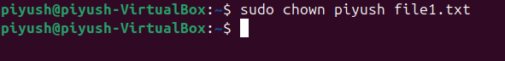
To change both the owner and group, use:
sudo chown username:groupname filename
Special Permissions in Linux
Linux has three special permissions:
- SetUID (s) – Allows users to execute a file as the owner.
- SetGID (s) – New files inherit group ownership.
- Sticky Bit (t) – Prevents users from deleting others' files in shared directories.
Applying Special Permissions
SetUID Example
Allows non-root users to run a file with root permissions:
chmod u+s script.sh
ls -l script.sh
Output:
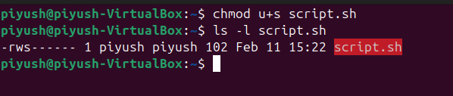
Used in system commands like passwd.
SetGID Example
Ensures that all new files in a directory belong to the same group:
chmod g+s /shared_directory
ls -ld /shared_directory
Output:
drwxr-sr-x 2 user group 4096 shared_directory
Used for shared project directories.
Sticky Bit Example
Used in public directories (e.g., /tmp) to prevent users from deleting each other’s files:
chmod +t /tmp
ls -ld /tmp
Output:
drwxrwxrwt 10 root root 4096 /tmp
Ensures files are deleted only by the owner.
Summary
Feature | Command
Edit SSH config | sudo nano /etc/ssh/sshd_config
Check SSH service | sudo systemctl status ssh
Enable SSH service | sudo systemctl start ssh
Generate SSH Key | ssh-keygen -t rsa -b 4096
Copy SSH Key to Server | ssh-copy-id user@remote-server
Enable UFW Firewall | sudo ufw enable
Allow SSH in Firewall | sudo ufw allow OpenSSH
Check Firewall Status | sudo ufw status verbose
Make a script executable | chmod +x script.sh
Change file owner | sudo chown user file.txt
Apply SetUID | chmod u+s script.sh
Apply SetGID | chmod g+s shared_directory
Apply Sticky Bit | chmod +t /tmp
System Administration and Troubleshooting in Linux
In this section, we’ll dive into essential performance monitoring tools, process management, and troubleshooting techniques to maintain a stable and efficient Linux system. As always, we’ll focus on Ubuntu in VirtualBox using GNU Nano 7.2 for editing configurations.
Performance Monitoring in Linux
Monitoring system performance is crucial to ensure that resources like CPU, memory, and disk usage are being utilized efficiently. Let’s explore some important tools for system monitoring.
Checking System Resource Usage
vmstat - Virtual Memory Statistics
The vmstat command provides an overview of CPU usage, memory, swap, and disk I/O. Run:
vmstat 5 10
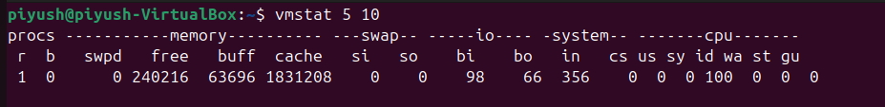
What happens here?
- 5 → Updates every 5 seconds
- 10 → Runs 10 times before stopping
This helps analyze system performance over time.
htop - Interactive Process Monitoring
Unlike top, htop provides a user-friendly interface for monitoring processes.To install and use it:
sudo apt update
sudo apt install htop -y
htop
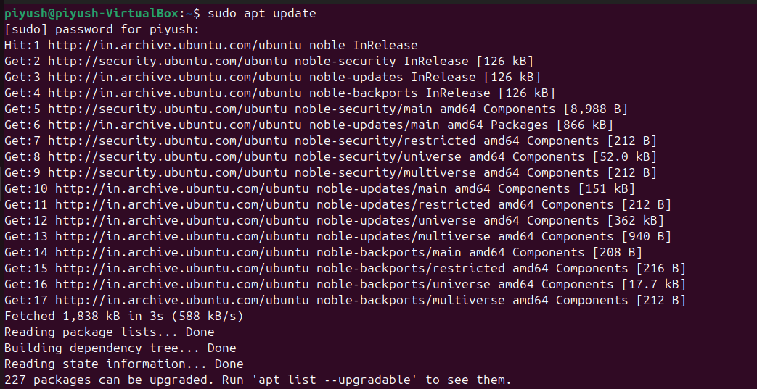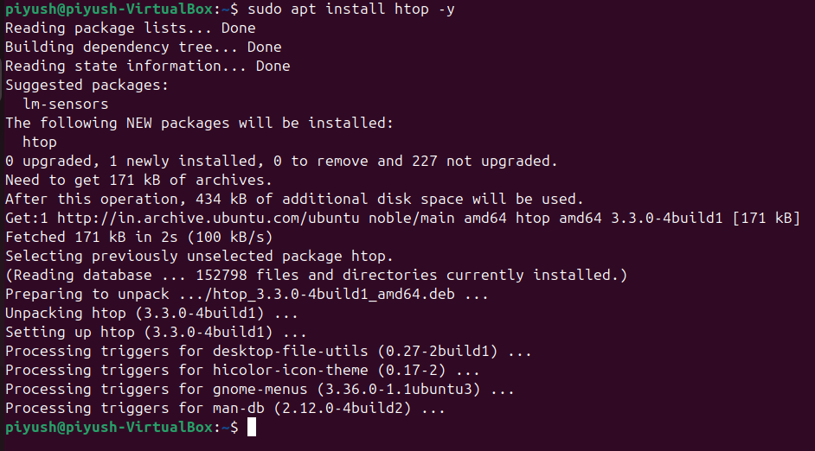
Use the arrow keys to navigate and F9 to kill processes.
free - Checking Memory Usage
To check RAM usage in a human-readable format:
free -h
Output:
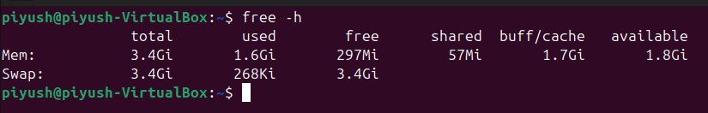
This helps diagnose memory leaks or excessive RAM usage.
Managing Running Processes & Services
Linux allows us to control running processes efficiently.
Check Running Processes
ps aux | less
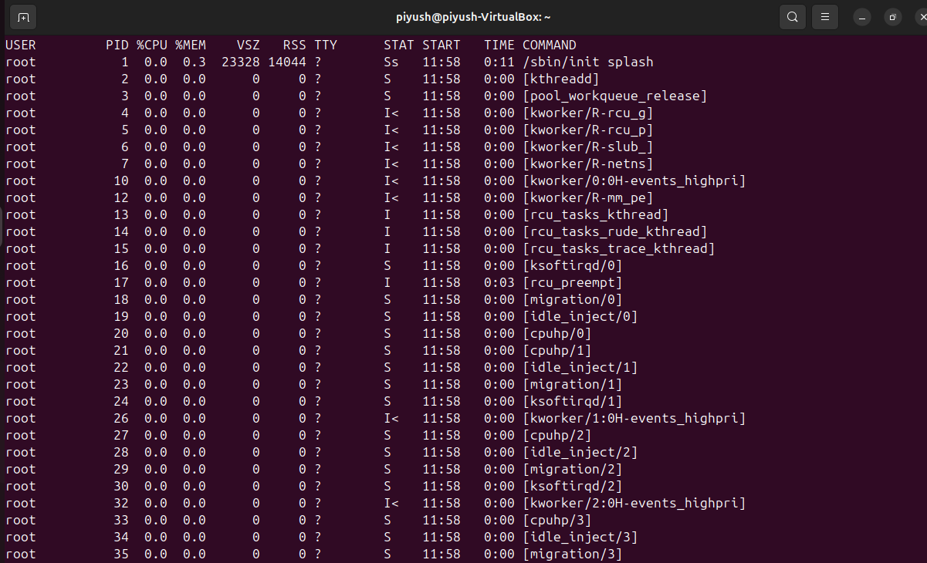
- ps aux → Lists all processes
- less → Helps scroll through output
Kill a Process
Find the PID of the process and kill it:
ps aux | grep firefox
kill <PID>
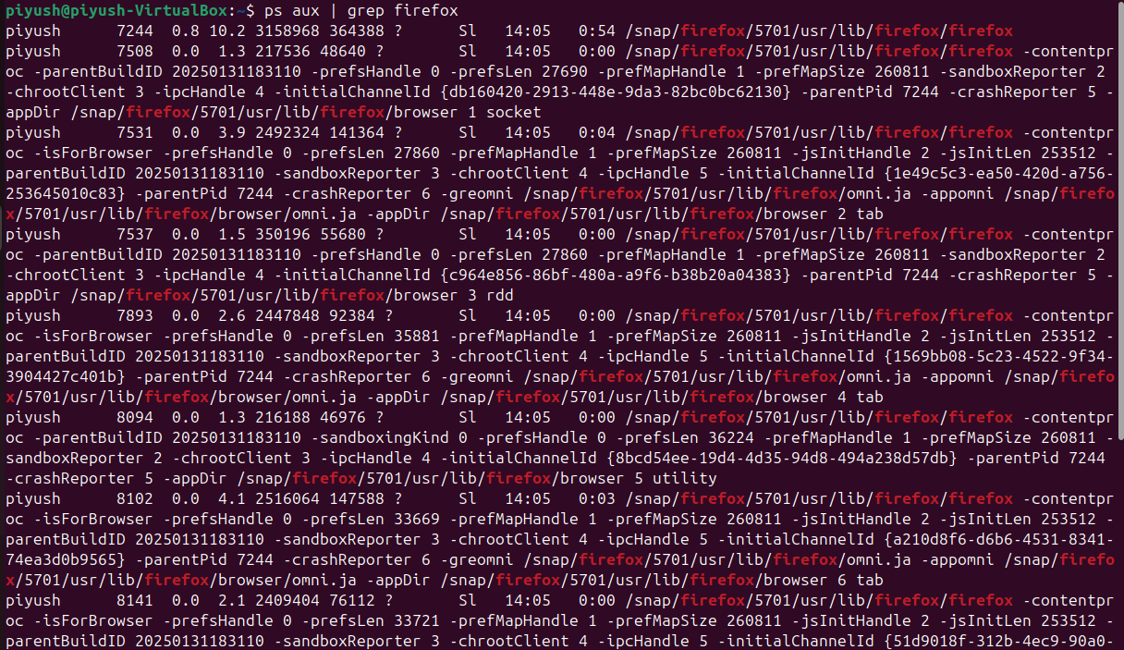
Managing Services (systemctl)
To check if a service (e.g., SSH) is running:
systemctl status ssh
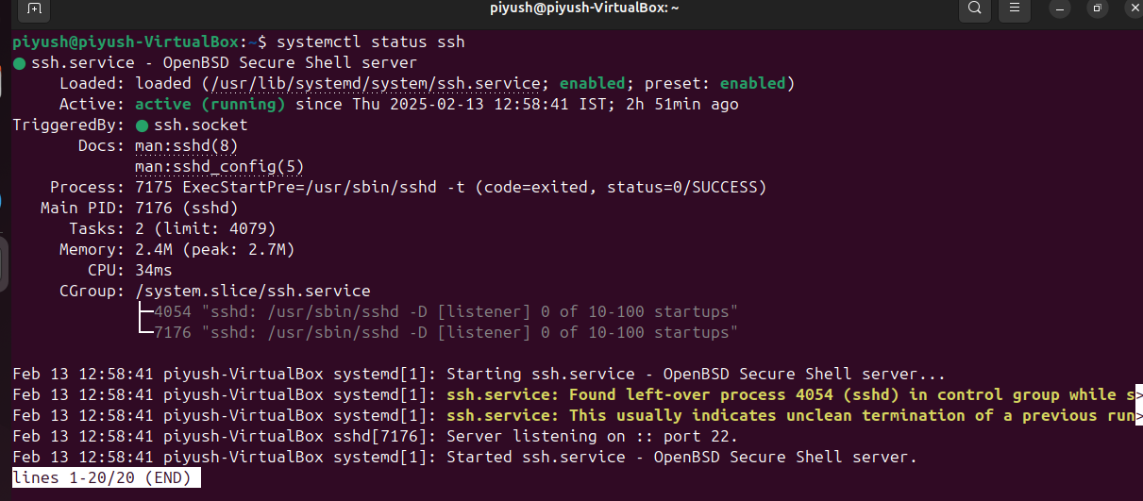
To restart a service:
sudo systemctl restart ssh
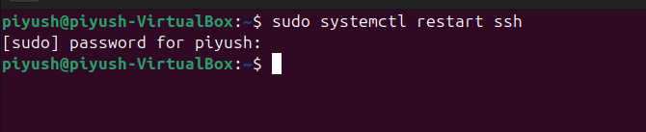
Troubleshooting Techniques
When something goes wrong in Linux, knowing where to look is key. Let’s explore debugging tools and system logs.
Debugging Tools
strace - Trace System Calls
If an application is behaving unexpectedly, use strace to debug:
strace -c ls
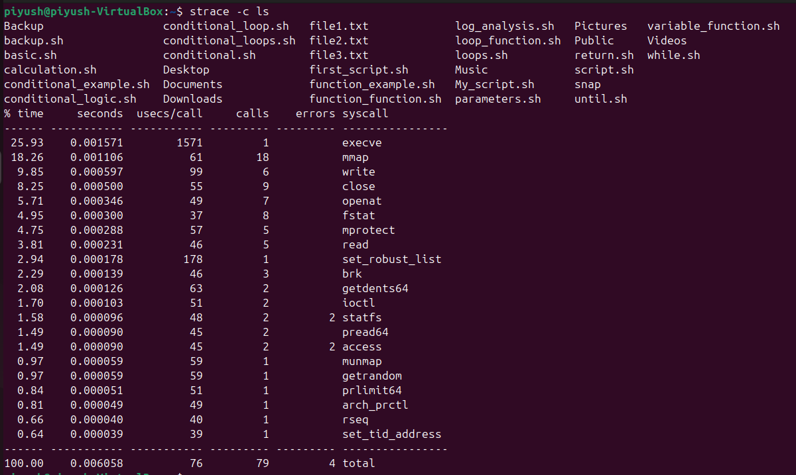
This shows which system calls ls is making.
lsof - List Open Files
To see which files are open by a process:
lsof -p <PID>
This is helpful when diagnosing file-related issues.
dmesg - Kernel Logs
To check system boot and hardware logs:
dmesg | less
Use this for debugging hardware issues.
Analyzing System Logs (/var/log/ Directory)
Linux stores system logs in /var/log/. Let’s explore some important logs.
Check Authentication Logs
cat /var/log/auth.log | less
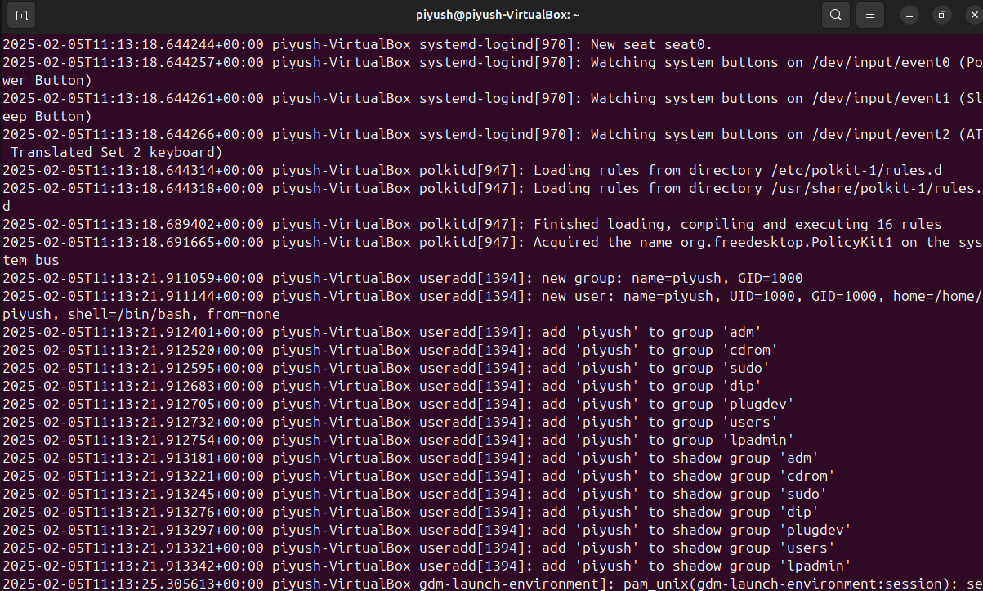
Use this to track SSH login attempts.
Check System Logs
cat /var/log/syslog | less
This file logs system events and errors.
Check Kernel Logs
cat /var/log/kern.log | less
Use this to diagnose kernel-level issues.
Summary of Key Commands
Task | Command
Check CPU & Memory Usage | vmstat 5 10
Monitor Processes (GUI) | htop
Check Memory Usage | free -h
List Running Processes | `ps aux
Kill a Process | kill <PID>
Restart a Service | sudo systemctl restart <service>
Trace System Calls | strace -c <command>
List Open Files for a Process | lsof -p <PID>
Check System Logs | `cat /var/log/syslog
Check Authentication Logs | `cat /var/log/auth.log
Check Kernel Logs | `cat /var/log/kern.log

